Will You Take a Stand for Justice?
Support Healing and Peace in Oakland for the death of Oscar Grant! 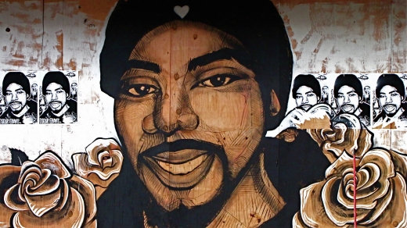

You are invited to

Eastside Arts Alliance
2277 International Boulevard
Thursday, September 23, 2010
5:30pm – 8:30pm

Meet / Greet / Dinner 5:30pm to 6:00pm
Dialogue/Training 6:00pm to 8:30pm
Spoken Word 8:30pm - until

Receive a Certificate of Participation for attending a Dialogue / Training
Attend three trainings and receive a Peace Keeper Certificate of Completion

All Trainings are FREE and open to the public

RSVP http://communitydialogueandpeacekeepertraining.eventbrite.com or call Mutima Imani at 510-205-4069 or via email to mutima.imani@sbcglobal.net
